Cardio Respiratory Endurance

The ability of the heart, lungs, and blood vessels to use and send fuel to the body’s tissues during long periods of moderate to vigorous activity.
Assessment: Mile Run, Pacer
FITT Principle for Cardiorespiratory Endurance:
Frequency: 4-5 days per week
Intensity: 60% to 85% of target heart rate zone
Time: 30 to 60 minutes is recommended.
Type: Any aerobic activity that keeps the heart within your target heart rate zone
Muscular Strength

The amount of force a muscle can exert.
Assessment: Pull-Ups, Push Ups
FITT Principle for Muscular Strength:
Frequency: 2-3 days per week on non-consecutive days
Intensity: Heavy weight with more sets with decreasing reps
Time: Slow and controlled movement throughout range of motion
Type: 8-10 exercises targeting major muscle groups
Muscular Endurance

The ability of the muscles to perform physical tasks over a period or time without becoming fatigued.
Assessment: Curl Ups
FITT Principle for Muscular Endurance:
Frequency: 2-3 days per week
Intensity: Maintain or lower weight while increasing or decreasing sets with more reps
Time: 30 to 60 minutes is recommended
Type: Weight lifting activities

Flexibility

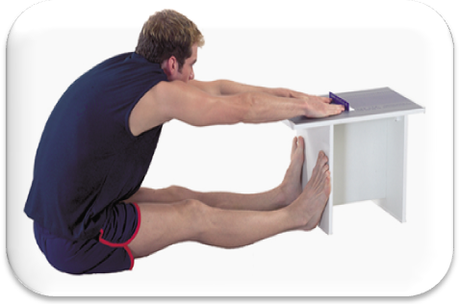
The ability to move the joints through a full
range of motion.

Assessment: The Sit and Reach

FITT Principle for Flexibility:
Frequency- Daily stretching is recommended
Intensity- stretch muscles and hold beyond its normal length at a comfortable stretch
Time- hold each stretch for 10-15 seconds with the stretching workout lasting 15 min
Type- static stretches that allow the body to move through the full range of motion

Body Composition

Ratio of Lean Tissue to Fatty Tissue

Assessment: Skin Calipers, Hydrostatic Weighing, BMI

